Homework Lesson 17

Angelika Kryvoruchenko

Level 1

Basic Car Search

Steps:

1.Go to website <https://www.carsforsale.com/>

2.Choose a car model such as BMW

3.Choose a model such as 2 series 437

4..Click Find yours button

Expected Result

List of cars is returned

Location Proximity Car Search

Steps:

1.Go to website <https://www.carsforsale.com/>

2.Choose a car model such as BMW

3.Choose a model such as 2 series 437

4.Click Find yours button

5.Enter a Zip code such as 90210

6.Reduce the search radius to 25 miles

Expected Result

List of cars is returned which is restricted to the search area of 25 miles of entered zip code

Filtered Car Search

Pre Req

A user has performed a basic search and is on the search page

Steps:

1. Adjust the price slider to 30000
2. Adjust the mileage slider to 50 000
3. Adjust the year slider 2016 and older

Expected Result

List of cars is returned which is restricted to the search filter criteria entered above

Specific Car Details

Pre Req

A user has performed a basic search and is on the search page

Steps:

1. A user selects the top car result by clicking the photo

Expected result:

A user is presented with detailed information about the car

Make an offer

Pre Req

A user has performed a basic search and has clicked on a car photo for specific details

Steps:

1. A user clicks on a making offer button

Expected Result:

A modal dialog is presented to the user

Level 2

With <https://reqbin.com/>, test the following API [Reqres](https://reqres.in/) methods:

* + LIST USERS - No issues
  + SINGLE USER - No issues
  + CREATE - No issues
  + UPDATE (PUT) - No issues
  + UPDATE (PATCH) - No issues
  + DELETE - No issues
  + REGISTER - SUCCESSFUL - No issues
  + LOGIN - SUCCESSFUL - No issues

Level 3

<https://gorest.co.in/public/v2/users/344/posts>

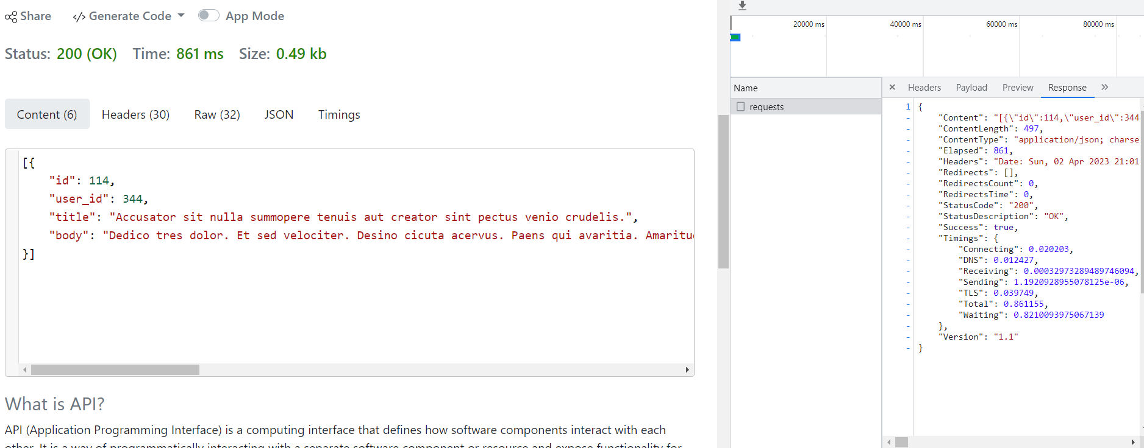

POST /public/v2/users

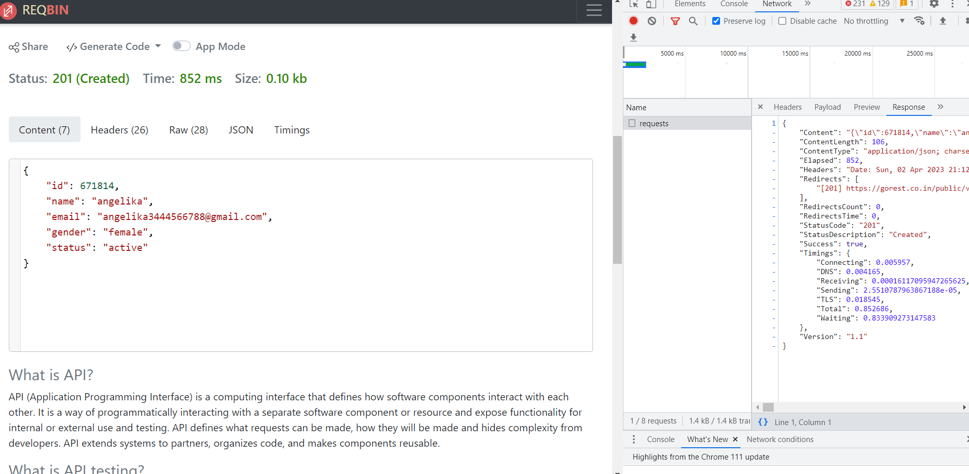

PUT|PATCH /public/v2/users/671814

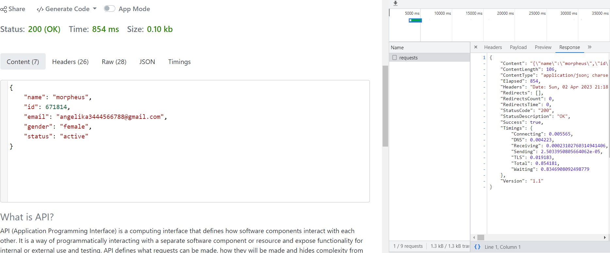

DELETE /public/v2/users/671814

